[](http://www.google.co.uk/url?sa=i&rct=j&q=&esrc=s&source=images&cd=&cad=rja&uact=8&ved=0ahUKEwiwn-vbmKLWAhVMBsAKHfYyDHUQjRwIBw&url=http://www.cpft.nhs.uk/Latest-news/Take-part-in-Health-and-Wellbeing-Week-at-CPFT&psig=AFQjCNEylJr5jdZTnh2ibJe6-SPABrqzIQ&ust=1505393137353221)

**Memory Skills Workbook  
Session 6: Wellbeing, Course Review & Goodbyes**

**Course Overview**

Session 1 Introductions and an overview of cognitive abilities

Session 2 Overview of memory

Session 3 External memory enhancement strategies

Session 4 Internal memory enhancement strategies

Session 5 Mood and cognitive functioning

**Session 6 Keeping well, course reviews and goodbyes**

**Mindfulness**

As we said in the last session, when you come into each session there may be lots of things on your mind. You might have thoughts about what you’ve been doing, what you need to do, maybe some expectations or perhaps worries about what the group itself will be like. Our minds often wander and life is sometimes filled with stresses or worries. To start off today, and at the beginning of our future sessions, we will carry out a brief breathing exercise. The aim of this is just to help us be more present ‘in the moment’, and give us some time to become more aware of our thoughts, feelings and any physical sensations. As we’ll see later in the course, this can also support our cognitive functioning and help our memory along with promoting overall well-being. If you have difficulty focusing on the breath (e.g. due to breathing difficulties) then go at a pace that feels comfortable to you, stop the meditation or focus on another part of your body, such as your feet.

[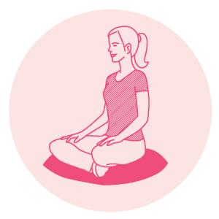](https://www.google.co.uk/url?sa=i&rct=j&q=&esrc=s&source=images&cd=&cad=rja&uact=8&ved=0ahUKEwjLicur37DWAhVLOxQKHZUEBNQQjRwIBw&url=https://www.mindful.org/meditation/mindfulness-getting-started/&psig=AFQjCNGp_64PMIuSWCwmF9rcWph0tM3psA&ust=1505893155465835)

**Introduction**

The purpose of today’s session is to bring together the information and skills we have developed during the course. It’s also a chance to reflect on how we can apply the skills developed in the future.

During the programme we have discussed the impact of mood on cognitive functioning, and in turn the impact our cognitive functioning can have on our mood. During session 5 we identified the links between our thoughts-feelings-body sensations-behaviour. We identified some ‘unhelpful thoughts’ about our memory and ourselves, and thought about how to challenge these. We also had an introduction to the benefits of mindfulness. Both of these skills can help us to maintain good mental health and wellbeing. This is important for our cognitive functioning generally and memory in particular.

It’s also really important to consider how we can maintain good physical and emotional health – our general well-being. This is because our cognitive functions do not operate in isolation: they are impacted by our physical health. For example, our heart and blood vessels carry important oxygen and nutrients to brain cells, vital for efficient cognitive functioning. During today’s session we will think about what we can do to promote our physical and emotional well-being.

[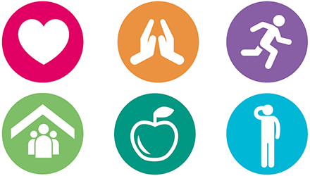](http://www.google.co.uk/url?sa=i&rct=j&q=&esrc=s&source=images&cd=&cad=rja&uact=8&ved=0ahUKEwiDxcTL4rDWAhVHvxQKHSWgD6IQjRwIBw&url=http://www.dulwich.org.uk/college/academic/wellbeing&psig=AFQjCNExgKM0Xm1iiinxujZRtal0LmGR9w&ust=1505894016170242)

[](http://www.google.co.uk/url?sa=i&rct=j&q=&esrc=s&source=images&cd=&cad=rja&uact=8&ved=0ahUKEwjlmrqxgaLWAhWpKsAKHVbXAYAQjRwIBw&url=http://keywordsuggest.org/82800-healthy-food-icon.html&psig=AFQjCNGloCRyzudnSKveelj-mQ1VVrnXKg&ust=1505386902157475)**Diet**

Eating a varied and well-balanced diet is good for our general well-being – a mix of plenty of carbohydrate, plenty of fresh fruit and vegetables some protein and dairy if possible (or other sources of calcium), and just a small amount of food/drinks that are high in fat or sugar. The plate below shows a healthy balanced diet, which helps to keep cholesterol and blood pressure low. It can also support our cognitive functioning.

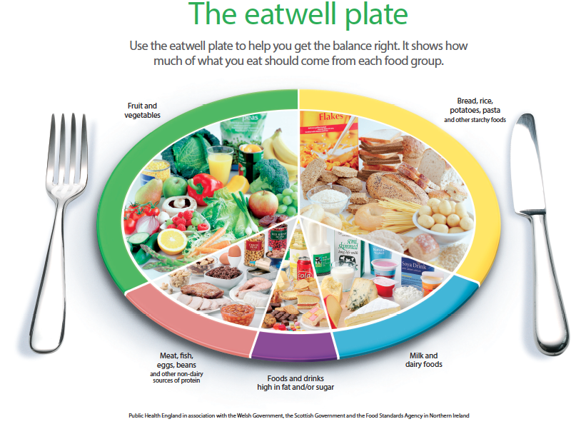There has been lots of research into what particular food groups or nutrients may support cognitive functions and memory. There are also certain foods that can help promote a healthy brain such as Omega 3 fatty acid (nuts, seeds, olive oils and oily fish) and antioxidants (broccoli, blueberries and spinach). There is some evidence that B vitamins, especially B12, may also support memory functioning as we get older. Overall it seems that a healthy, varied diet is important rather than any one food group alone.

[](http://www.google.co.uk/url?sa=i&rct=j&q=&esrc=s&source=images&cd=&cad=rja&uact=8&ved=0ahUKEwjNkc2ogaLWAhWmCcAKHZ2sBvYQjRwIBw&url=http://health.usnews.com/health-news/blogs/eat-run&psig=AFQjCNHhwROYpsPqdWim5ShL887SbADj_A&ust=1505386789027438)

**Exercise**

Regular exercise helps to improve our overall health and reduce the risk of developing illness or health problems that impact on cognitive functioning. Research shows that several cardiovascular risk factors (including obesity and high blood pressure) are also risk factors for cognitive decline, so exercise can aid both physical and cognitive well-being.

Exercise also improves the flow of blood and oxygen to the brain, helping us to perform better mentally. It boosts the release of endorphins, or so-called ‘feel good’ hormones; and lots of research suggests that it can have a good impact on our emotional well-being and symptoms of stress, anxiety or low mood.

Current guidelines recommend that adults take part in moderate exercise for the equivalent of 30 minutes, 5 days a week (or 75 minutes of more vigorous exercise spread across the week). Moderate exercise means doing something that raises your heartbeat, but that you can do whilst holding a conversation.

[](http://www.google.co.uk/url?sa=i&rct=j&q=&esrc=s&source=images&cd=&cad=rja&uact=8&ved=0ahUKEwjI-JmSgKLWAhVFGsAKHQkhA5kQjRwIBw&url=http://www.istockphoto.com/illustrations/jogging&psig=AFQjCNGI2vguLgq-pBerrTf0BaswVz57ag&ust=1505386522076966)Examples include going for a brisk walk or pushing the lawnmower, so it may be easier than we sometimes think to incorporate exercise into our daily routine. For example, getting off the bus a stop early or walking to the shop rather than driving all count. Like all skills, it will take some time to notice the benefits that exercise brings, but keeping going on a regular basis will maximise those benefits.

[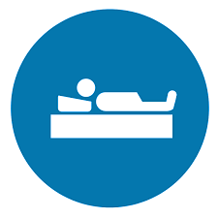](http://www.google.co.uk/url?sa=i&rct=j&q=&esrc=s&source=images&cd=&cad=rja&uact=8&ved=0ahUKEwih-PCvgqLWAhVENxQKHeLYCjcQjRwIBw&url=http://www.heritagesleep.net/&psig=AFQjCNGux0E7xTx6RzUMVOC9mMHnlDtl5Q&ust=1505387162682865)

**Sleep**

Sleep is very important and can play a huge part in the memory process. If we are feeling tired then this can make our memory worse. You may notice that when you have had little sleep it is difficulty to focus on a task or to retain information. It is recommended that you have around 6-9 hours, but this can differ from each person. There are some tips below to help you have good sleep hygiene.

* Try to go bed at the same time each night and wake up at the same time.
* Avoid caffeine, alcohol, nicotine and heavy meals before going to sleep.
* Try to do regular physical exercise, but avoid this 2 hours before bedtime.
* Have a warm bath before bed time.
* Try some relaxation exercises such as mindfulness or light yoga.
* Try to make your bedroom a relaxing environment- avoid electronics, noise and light.

[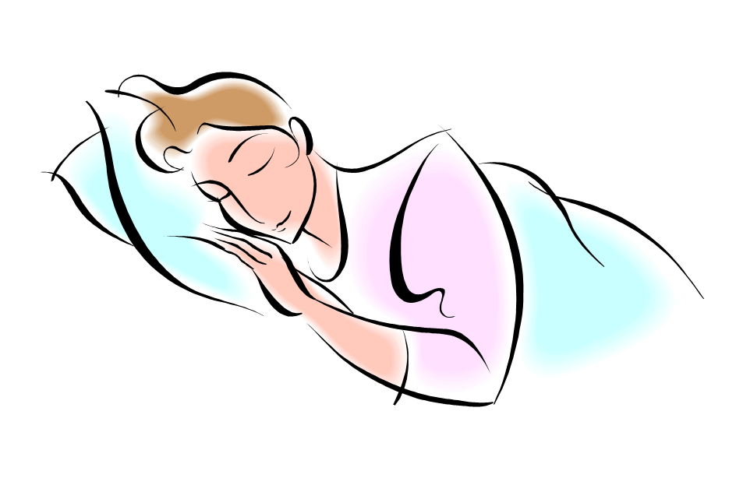](http://www.google.co.uk/url?sa=i&rct=j&q=&esrc=s&source=images&cd=&cad=rja&uact=8&ved=0ahUKEwi5__C3-6HWAhXpJsAKHVxoDuAQjRwIBw&url=http://www.picquery.com/animated-people-sleeping_hKXERpv*lQ78xbjHmQfH64Vm1d1iXPf3bcY7tO0sl1k/&psig=AFQjCNGdvm5R1lV-k8H4gUIbBoyB28jHLA&ust=1505385298125476)

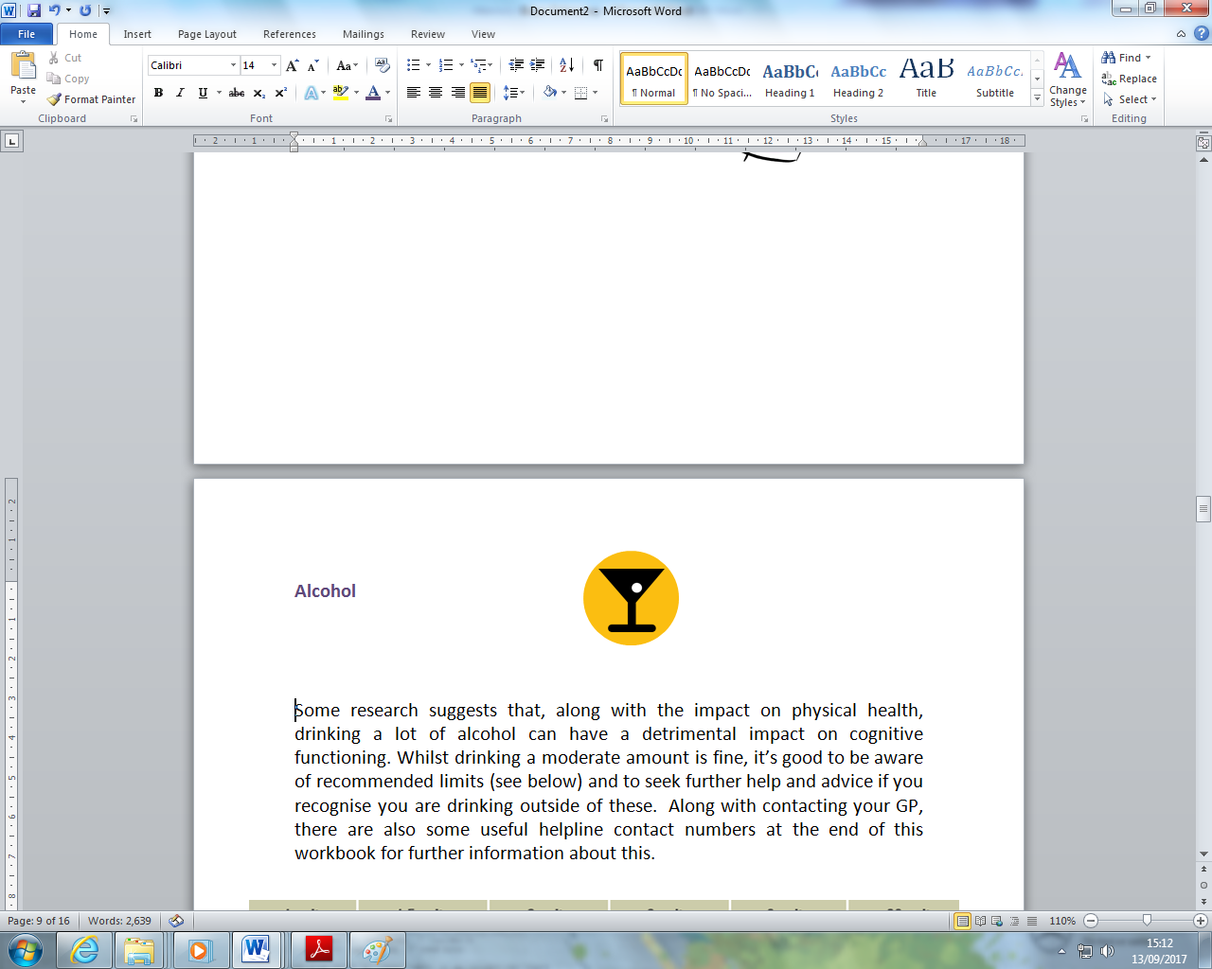**Alcohol**

Some research suggests that, along with the impact on physical health, drinking a lot of alcohol can have a detrimental impact on cognitive functioning. Whilst drinking a moderate amount is fine, it’s good to be aware of recommended limits (see below) and to seek further help and advice if you recognise you are drinking outside of these.

[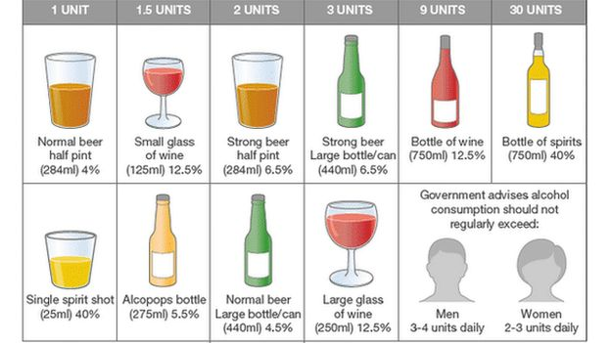](http://www.google.co.uk/url?sa=i&rct=j&q=&esrc=s&source=images&cd=&cad=rja&uact=8&ved=0ahUKEwjWm4HvsKLWAhUHchQKHaXPCQwQjRwIBw&url=http://www.bbc.co.uk/news/health-32841273&psig=AFQjCNF2VTfg_dlRfhvaJSeB1tuudG0BmA&ust=1505399550293938)

[](http://www.google.co.uk/url?sa=i&rct=j&q=&esrc=s&source=images&cd=&cad=rja&uact=8&ved=0ahUKEwilqq2trKLWAhVGsxQKHYKiBoUQjRwIBw&url=http://www.istockphoto.com/photos/no-smoking-sign&psig=AFQjCNFCZH02jBUCwCszxadGXyr2iDG1Aw&ust=1505398427238305)

**Smoking**

Smoking is another cardiovascular risk factor. This means that it increases the chance of issues such as stroke, which can affect cognitive functioning and memory. It also increases the risk of several other physical health problems. If you want any further information for support in stopping smoking, speak to one of the facilitators.

[](https://www.google.co.uk/url?sa=i&rct=j&q=&esrc=s&source=images&cd=&cad=rja&uact=8&ved=0ahUKEwjG-Zy6r6LWAhUByRQKHcFvD5gQjRwIBw&url=https://www.shareicon.net/mug-hot-drink-tea-cup-food-and-restaurant-coffee-tea-food-875036&psig=AFQjCNE-KbiH7EUt4o4OLqwiTLsrPpphGQ&ust=1505399271083162)

**Caffeine**

Large amounts of caffeine can have an impact of your sleep, which in turn

can have an impact of your cognitive functioning. Some evidence suggests that excessive caffeine can have a negative effect on short term memory. Caffeine can be found in tea, coffee, chocolate, some fizzy drinks and energy drinks.

**Emotional Wellbeing**

Our physical, mental and emotional well-being are all linked. Many of the tips to improve physical health can also promote good emotional well-being. For example, keeping active and doing the things we enjoy has multiple benefits: it ensures we get a good amount of cognitive stimulation; it provides opportunity to use our cognitive abilities; and chance to practice strategies to support memory; and it also improves mood.

Just as we devote time to ensuring our physical health is as good as it can be, we can take some time to look after our emotional well-being too. As we discussed last session, how we feel can have a positive impact on our cognitive functioning and memory.

Looking after our emotional and mental well-being may involve doing things that help us to relax, take time out and feel good about ourselves. These needn’t be big things; some examples could be:

* Doing a relaxation exercise
* Reading a book
* Having a long shower or bath

[](http://www.google.co.uk/url?sa=i&rct=j&q=&esrc=s&source=images&cd=&cad=rja&uact=8&ved=0ahUKEwjNxu61s6LWAhXHzxQKHeD9DrsQjRwIBw&url=http://www.istockphoto.com/illustrations/two-men-talking&psig=AFQjCNEPK7UbKmIGpAsiINLvKywCWLYa8A&ust=1505400332960638)

* Having a nice meal, and really taking time to enjoy it

* Walking and playing with a pet
* Phoning a friend or going out for a catch up
* Painting, making a collage, knitting, writing or drawing – anything you find soothing

Regularly practicing a mindfulness relaxation exercise, like those we have introduced during the programme, can also support our general well-being. If this is something that interests you, you can listen to CD of some mindfulness relaxation exercises. Listening to these and deciding which work best for you, along with practicing frequently, can help you to gain the benefits of these exercises. As we’ve discussed, these exercises can also help us to become more aware of our thoughts, feelings and physical sensations and become more aware of where we focus our attention.

A key point is taking a holistic approach – our cognitive functioning is impacted by other parts of our well-being, so looking after all and making small changes in one area can have a positive impact on others.

If it is difficult to make time for these activities, making a plan might help. Some people find it useful to plan time in the diary or calendar for them, as you would other appointments and meetings. For others the Toolbox approach might be helpful[1].

[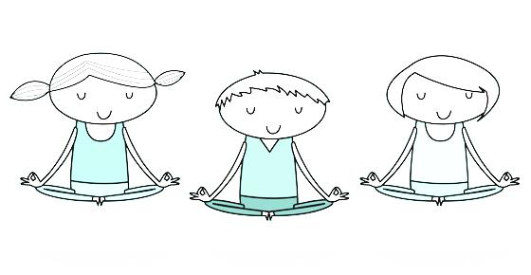](http://www.google.co.uk/url?sa=i&rct=j&q=&esrc=s&source=images&cd=&cad=rja&uact=8&ved=0ahUKEwjUh4u96rDWAhUFQBQKHbKCC2IQjRwIBw&url=http://vitalkidsmedicine.com/practicing-mindfulness-within-the-hectic-day/&psig=AFQjCNGUggo4lz3qRQKG12zIpazYA6obMg&ust=1505896086124678)

**Reviewing our work; or, putting together our ‘toolbox’**

Now we are coming to the end of the programme, it can be helpful to take some time to review what we have covered. Take some time to remind yourself of all the skills and information we have looked at (it may help to have a review over this booklet!) Remind yourself of our sessions:

**Session 1** Initial overview of cognitive processes – attention, information processing, executive functioning, visuo-spatial skills and language

**Session 2** Focus on memory processes – attention, information processing, encoding, storage and retrieval

**Session 3 E**xternal memory enhancement strategies – adapting our **e**nvironment to support memory. Discussing our memory difficulties.

**Session 4 I**nternal memory enhancement strategies – drawing our **i**nner resources to support memory

**Session 5** Mood and cognitive functioning

**Session 6** General well-being and cognitive functioning – physical and emotional health

There’s been a lot to take in. As we discussed at the start of the course, different bits of information and skills will feel most useful and relevant to different people. When it comes to memory enhancement strategies, a bit of a ‘trial and error’ approach can help us to try out different skills and work out what works best for us.

At this point it can be really helpful to plan how we might take forward and develop the skills and information discussed during the programme. Just like a toolbox, we can now put together our strategies or ‘tools’ to help support our memory

|  |  |
| --- | --- |
| **Prepare** | Decide what you are going to do, when, how and who with. Set time aside each day, perhaps in the evening, to plan the next day. Be realistic in what you hope to achieve – don’t put too much pressure on yourself. |
| **List** | Prioritise what would be the most important, most urgent, most helpful, most effective thing to do. Write it down (use a weekly planner, a diary or notepad).  Try to make goals SMART (specific; measurable; attractive; realistic; time-bound) |
| **Action** | Do it! Put your plan into action. |
| **Notice** | Notice how the activity affects you. If it was unhelpful, then ask yourself if you could have done anything differently, or maybe decide not to do it again. If it has a helpful or positive effect, then plan to do more. What else could you do? |

[](http://www.google.co.uk/url?sa=i&rct=j&q=&esrc=s&source=images&cd=&cad=rja&uact=8&ved=0ahUKEwj1xNyR87DWAhWB6xQKHVwEDDkQjRwIBw&url=http://www.osec.doc.gov/opog/OG/&psig=AFQjCNEY6aS8V0DeTqrdxB2pFVIsFW5Eag&ust=1505898477951896)

|  |
| --- |
| **Memory ‘Toolbox’** |
| **The parts of my memory that I have identified I have the most difficulty with are:** |
| **The parts of my memory that I have identified are my strengths are:** |
| **External memory strategies are those which involve making adaptions to our environment to support memory.** |
| **External memory strategies that I have identified I will put into practice in the future are:**  *(A good tip is to look at your strengths and difficulties. For example, if your difficulty is retrieving information and visual memory is a strength, using a calendar or diary may help to recall information; drawing pictures or using photographs around the house may also help remind you to do things)* |
| **Internal memory strategies are those which involve our inner resources** |
| **Internal memory strategies that I have identified I will put into practice in the future are:**  *(Review your strengths and difficulties. Using the example above, associating words or numbers with images or using the method of loci may help to retrieve information from long term memory stores)* |
| **If I notice an unhelpful thought about my memory, I could say to myself:**  *(Remind yourself of the more helpful, alternative thoughts from session 5)* |
| **Three things I can do to look after my physical and emotional well-being to support my memory functioning are:** |

**Saying our goodbyes**

The aim of this group was to help you learn more about your memory, to identify strengths and any difficulties and to think together about some strategies to help manage difficulties. We also hope that the group has provided you with the space to share your experiences, knowledge and skills.

Remember that it takes time to identify and implement new strategies and it can take time for these to work so be patient and allow yourself time to adjust. It can also take time to practice and consolidate these skills. However, using them on a regular basis will give them the best chance of becoming effective.

Sometimes attending groups and saying goodbye can cause us to have difficult thoughts and feelings. If you’re experiencing any difficulties please feel able to arrange a time to discuss this with Grace. We will endeavour to be available for telephone consultation on 01782 275188 to support you if you are having difficulties due to the group.

Thank you for taking part in this group programme. We hope that you have learned things that will be helpful now and in the future.



|  |
| --- |
| Use the space below to write notes if needed: |
|  |
|  |
|  |
|  |
|  |
|  |
|  |
|  |
|  |
|  |
|  |
|  |
|  |
|  |
|  |
|  |
|  |
|  |
|  |

1. Adapted from www.getselfhelp.co.uk